CDA 3103 Computer Organization Homework

**Section I: Problems**

1. (10 points) Assume the output of the decoder in the following picture is ordered as 0 to 7 from top to bottom. Write the Boolean function implemented in Canonical Sum-of-Product format and Canonical Product-of-sum format.



1. (15 points) Write a simplified Boolean function for the function performed by the circuit below. Show detailed steps to earn full credits for Boolean function simplification.



1. (20 points) Using a 4X16 decoder module and a OR gate to implement the Boolean function $f(a,b,c,d) = abc’ + a'cd$.
2. (15 points) Using an 8X1 multiplexer module to implement the Boolean function $f\left(a,b,c\right)=b+ac'$.
3. (20 points) Using an 4X1 multiplexer module to implement the Boolean function $f\left(a,b,c\right)=b+ac'$.
4. (20 points) Complete the truth table for the following sequential circuit:

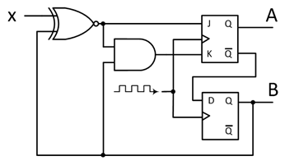

|  |  |  |  |  |  |  |  |
| --- | --- | --- | --- | --- | --- | --- | --- |
| *X* | *QA(t)* | *QB(t)* | *J* | *K* | *D* | *Next State* | |
| *QA(t+1)* | *QB(t+1)* |
|  |  |  |  |  |  |  |  |
|  |  |  |  |  |  |  |  |
|  |  |  |  |  |  |  |  |
|  |  |  |  |  |  |  |  |
|  |  |  |  |  |  |  |  |
|  |  |  |  |  |  |  |  |
|  |  |  |  |  |  |  |  |
|  |  |  |  |  |  |  |  |

**Section II: Submission Requirements**

The following requirements are for electronic submission via Canvas.

* Your solutions must be in a single file with a file name yourname-module3-assignment-2.
* Upload the file by following the link where you download the homework description on Canvas.
* If scanned from hand-written copies, then the writing must be legible, or loss of credits may occur.
* Only submissions via the link on Canvas where this description is downloaded are graded. Submissions to any other locations on Canvas will be ignored.